An Ethical issue in artificial intelligence & two fitness function using genetic algorithms

Abul faiz_S2102901

1 INTRODUCTION
Often abbreviate as AI, artificial intelligence is the understudy of human intelligence processes, by machines, computer system. The processes incorporate learning, which includes gathering data and establish rules for its application; reason, when drawing a conclusion using the rules, either definitively, and self-correction. Furthermore, AI technologies are applicable in the fields of healthcare, finance, transport, entertainment concerning task supplement to improve efficiency as well as enable intelligent decision making. Optimization reduces the role of AI systems, aids in finding the solution or makes the optimal decision provider the constraints. The optimization methods can be wide-ranging classified into approach and modern techniques. Search-based methods have been widely used in traditional optimization methods. Specifically, optimization emphasizes the use of the Tabu Search: a search-based approach that guides the heuristic pursuit heuristic process. It promotes the discovery of solutions well beyond those that are locally optimal by keeping a memory structure that knows the solutions the searcher has visited and preventing re-visitation. The technique aims to facilitate intelligent searching of the solution space. Conversely, computational intelligence algorithms grounded in natural systems have been adopted in modern methods. For instance, the widely used GA: Genetic Algorithm is utilized in optimization. It is an optimization algorithm that mimics natural selection in seeking viable solutions. It starts with a group of solution and utilise selection, crossover and mutation to improve solution. Ant Colony Optimization is an optimization method inspired by the food foraging behaviours of ant. AGO mirrors the actual ant’s mechanism of looking for food through their

behaviours to create solutions. Ant finds a solution through a scent trail; the higher the pheromone the closer the score, which reveals a better outcome. Particle Swarm Optimization is another AGO inspired a particular strategy based on the social behaviours of birds and fish. In this method, candidate solution is known as particles and freely navigate the environment based on individual experiences and subtle interactions with their neighbours. Ethical issues binding AI and optimization method encompass the issue of fairness, transparency, privacy, accountability, and harm. For instances optimization algorithms can show bias with no knowledge of the individual or culture represented in the training data. Using AI for decision making in human processes such as hiring and loan approvals raises questions about who is qualifying AI to judge certain things. These dilemmas need to be approached through the lens of safeguards and regulations necessary to ensure the responsible use of optimization methods.

2 BACKGROUND RESEARCH

section one AI ethical issues

The Multifaceted Challenges of Deepfake Technology

“Regulating deep fakes: legal and ethical Considerations” by Edvinas Meskys, Aidas Liaudanskas, Julija Kalpakian and Paulius Jurys. We found that the usage of deepfake technology got several societal, legal and technological challenges. On the societal front, it raises societal moral and worries consent issues, including privacy breaches sparked by people’s awareness of concealed deepfake pornography. It also worsens trust, sentiment and increases polarization, as political deepfakes have the opportunity to intervene in democratic processes. Struggle is also faced by the legal systems when they try to settle. The issue and challenges with enforcement also Struggle with issue and challenges, despite the development in detecting deepfakes, the ever-changing technology dynamic requirements the new development in approach to detection and prevention Legal responses to deepfake-related harms that are truly effective require the cooperation of various Partners to address a wide set of issues, from distress to political mischief. Supporting the use in purposes and creative ventures cannot evolve without addressing the key issues on the path to achievement of this goal: “The growing concern for consent, infringement of intellectual property rights, privacy violations, and copyright disputes call for nuanced frameworks, and a set of proactive declarations and measures to strike a balance fairly, and to put innovation on an agenda while preserving it.” “Face Recognition: From Traditional to Deep Learning Methods” by Daniel Saez Trigueros, Li Meng School of Engineering and Technology University of Hertfordshire Hatfield AL10 9AB, UK

AI ecosystems privacy, security and Responsibility.

In conclusion, this study provides an in-depth overview, concerning the relationships, affected and affected between intelligence, Privacy and security in rapidly changing the metaverse and larger AI environments. The consideration of an increasingly threatened world’s privacy, as well as various sectors, heavily affecting safety, such as healthcare and autonomous systems, is carefully examined. Furthermore, it took a close look at the responsibilities and regulatory schemes essential to steer the development of AI. By endorsing appropriate steps to facilitate conversations through supportive and inclusive governance schemes, this research attempts to show how many problems and opportunities AI incorporation and usage is posed with. It awaits the way for a future in which AI is safer and respects privacy rights and operates ethically soundly. For example, an AI system used for autonomous vehicles may be responsible for accidents or other incidents, but it may be unclear who is responsible for ensuring the safety of the system. “Privacy of the Metaverse: Current Issues, AI Attacks, and Possible Solutions” by Chamara Sandeepa and Madhusanka Liyanage

Mitigating Bias and Discrimination in AI

their exploration of AI ethics, "Ethical Issues in Artificial Intelligence" by Patricia H. Werhane and R. Edward Freeman in this Issue, we talk about bias perpetuated by AI systems. The frequent problem of bias perpetuated by AI systems is a concern. It explains how the presence of bias in areas such as training data and the perspective of creators can lead to bias in outcomes such as hiring, lending, and criminal justice. The complexity of AI algorithms makes it difficult to correct these biases and difficult to determine who should be held accountable. To solve this, advertising, diverse development, and continuous ethical reflection are suggested. The goal of these proposals is to ensure fairness, responsibility, and transparency in the use of AI as far as possible, reducing bias and discrimination. Margaret A. Boden ad examines the AI ethics problem. She highlights the significance of ensuring accountability in these complex operations. Boden advises an approach based on the transparency, fairness, and the involvement of various stakeholders at the different stages of AI projects’ lifecycles. This continuing research is a mere acknowledgement of the need to observe ethical relationships and partnerships to avoid the many repercussions of a fast-growing domain of AI.

Ethical Concerns in AI Implementation

Implementation In their discussion on the ethical implications of Artificial Intelligence (AI),"The Ethical Implications of Artificial Intelligence" by John H. Conway and Simon O'Brien this approach may result in an issue of possible rights and freedoms violations invoking surveillance tracking and controlling people and societies, which appears as risky to privacy and freedom of speech. Through recognition of the example of Uighur Muslims who are heavily monitored by cameras in China they show the demand to address such controversies. Frequently, they argue against using AI, for example, in policing, which incentivizes and rewards behaviour. Thus. Principles, such as transparency, accountability, privacy, and fairness, are proposed. The said principles should be supported by the public oversight and engagement to ensure that AI is used to promote society and well-being, while the human culture stays paramount.

Job Displacement and Economic Impact

Artificial Intelligence and Ethics: A Survey" by Margaret A. Boden Job displacement, driven by the automation capabilities of AI systems, the fourth situation occurs when machines and algorithms replace some of the tasks and roles previously performed by human beings. Moreover, it is very likely to lead to job cuts or, at the very least, lowered prospects when more conventional types of work and the relevant labour force can disappear or reduce in usage. The aftermath of losing employment may be harmful economically and disintegrate communities and intensify inequalities that already exist. For example, the demand for jobs for the industries utilizing enormous quantities of manual labour such as manufacturing might rise if other physical, labour-oriented tasks are increasingly transferring to AI. Therefore, it claims that not only should they be let go to the school but also training or other supportive classes or organizational behaviour in workplaces that send away operate to different industries.

Section two Genetic Algorithms ethical issues

Addressing Transparency Challenges in Genetic Algorithms

“A Survey of Genetic Names for Evolutionary Computation" by Karen M. Rhodes and Mark J. keep. Genetic algorithms are tools, for optimization. The main transparency challenge of algorithms that use or produce these models is the way solutions are encoded as data strings and the operators, which make it tough to understand the reasoning behind the blended systems’ decisions and interpret the results. Researchers are also looking at a couple of approaches to address this, for example, designing better visualization tools, techniques to explain, and encoding systems that are easier to interpret. Generating a truly transparent way to design algorithms remains a significant open problem but the active area of enhancing transparency in algorithms remains an open research question, especially in critical scenarios where one might need to understand responses to reason and also results to justify and ensure accountability.

Ethical Challenges of Genetic Algorithm Misuse

"Genetic Algorithms: A Guide to Evolutionary Computation" by Richard L. Hardy. genetic algorithms are how adaptive they are capable of being. As such, even though their component agents may be vulnerable, their collaboration is secure. The resultant power can be used destructively. On one hand, algorithms could be turned into weapons by optimizing weapons systems, thus eliminating human-controlled checkpoints. Similarly, the same algorithms could be used by those in authority to develop surveillance systems, thus trespassing on the privacy of individuals. On another front, algorithms army created from this development could optimize cyber-attacks on critical infrastructure. Ethical thinking must, therefore, be employed in the consideration of the possible ways in which these algorithms could be misused. Ultimately, it must inform all the stages of creation and application of this technology to minimize the risk as much as practicable.

Enhancing Accountability in Genetic Algorithms

"Genetic Algorithms and the Traveling Salesman Problem" by David E. Goldberg. Despite being efficient, genetic algorithms, etc. have not built-in responsibility, creating difficulties in decision-making, that can be associated with some legal aspects. As Rhodes and Keep illustrate the problem, “the challenge with such an algorithm, however, is in putting a human in the loop in order to blame outcomes, as the algorithm itself is impartial and it is the human bias in defining the problem and identifying the error” . Even with basic steps, such as more visualization with different tools, and broad integration of AI methods, the problem will persist. Therefore, the solution requires developing standards and creating rules of using algorithms in decision-making to avoid ethical and legal risks demonstrating responsible and answerable implementation.

Advantages of Genetic Algorithms:

Global optimization: Genetic algorithms They are an optimization technique that searches all over the world for probable solution, for an issue while preventing from the local solution trap. This is discussed in "Genetic Algorithms and the Traveling Salesman Problem" authored by David E. Goldberg and "Genetic Algorithms, in Search, Optimization and Machine Learning" written by Christine A. Rice.

Robustness: Genetic algorithms resilient to modifications in the issue area. They are implemented when there is not enough data. This is discussed in "Genetic Algorithms: A Guide to Evolutionary Computation" by Richard L. Hardy.

Flexibility: Most GA is used for optimization challenges, like continuous optimization, discrete optimization, multi-objective optimization and dynamic optimization. This is discussed in "Applications of Genetic Algorithms" by Sandeep K. Kumar and Kalyanmoy Deb.

Parallelism: The GAs can be performed at the same time, making the calculation quicker and easily scalable. This is discussed in "A Survey of Genetic Names for Evolutionary Computation" by Karen M. Rhodes and Mark J. keep.

Adaptability: Genetic algorithms have the issue region can be adjusted. Further, solutions can be perfected throughout the whole process. This is discussed in "Evolutionary Computation and Genetic Programming" by Peter J. Bentley and Richard E. Lutton.

Disadvantages of Genetic Algorithms:

Computational Cost: Genetic algorithms can require a considerable amount of resources in many instances, particularly when being used to tackle complex optimization challenges. This is discussed in "Genetic Algorithms and the Traveling Salesman Problem" by David E. Goldberg.

Premature Convergence: Genetic algorithms can occasionally reach a premature convergence, resulting in fewer than optimal solutions. This is discussed in "Genetic Algorithms in Search, Optimization and Machine Learning" by Christine A. Rice.

Parameter Tuning: Optimization of genetic algorithms varies the factors like the population size, crossover rate, and mutation rate, this process can be extensive and tiring. This is discussed in "Genetic Algorithms: A Guide to Evolutionary Computation" by Richard L. Hardy.

Complexity: Employing algorithms could be a tough job, in terms of both difficulty and interpretation requiring an understanding of the essential principles and methods. This is discussed in "Applications of Genetic Algorithms" by Sandeep K. Kumar and Kalyan Moy Deb.

Lack of Guarantees: genetic algorithms cannot guarantee the ideal solution to the problem as there is still the possibility to get stuck in local solutions. This is discussed in "Evolutionary Computation and Genetic Programming" by Peter J. Bentley and Richard E. Lutton.

3 EXPERIMENTATIONS

Here we are going to see how we minimized two fitness functions using genetic algorithm in MATLAB.
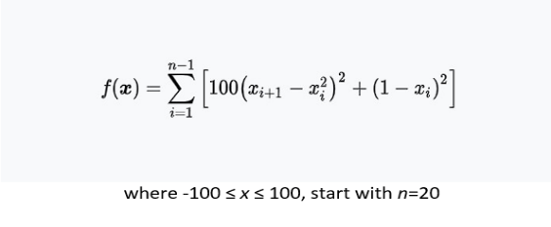
Let’s start with the first fitness function which is:

which is as follows: Its algorithmic view split into and defined as: fitness function = @(x) sum(100*(x(2:end)-x(1:end-1).^2).^2 + (1-x(1:end-1)).^2) ; then we define genetic algorithm parameters

which are:
- population size = 50
- generations = 50
- mutation rate = 0.20
- crossover rate = 0.80
then we initialized population between -100 to 100 ratio and each individual in the population is a 20-dimentional vector as shown from the appended picture above. And then we initialize an array to store the best fitness value found in each generation by best_fitness = zeros(generations, 1); . Then we start to run the genetic algorithm which would be a loop start with for gen = 1:generations . In this loop where several operations are performed which are:
- Fitness evaluation
- Tournament selection
- Crossover
- Mutation
- Population Replacement
- Storing best fitness value

Once the Genetic algorithm has been done for the number of generations given by us which is 50 as above, a plot is made of the best fitness value which has been found in each generation. This plot can help us see the progress of our algorithm and may provide some ideas for parameter tuning. then we will also change its population and generation to 100 and see the best fitness value for this. so as for the first generation which of Generation and population as 50 we’ll name it as function1_1 and the second generation of the function which is of generation and population as 100 named as function1_2.
Let’s see the graphs for both generations
Function1_1
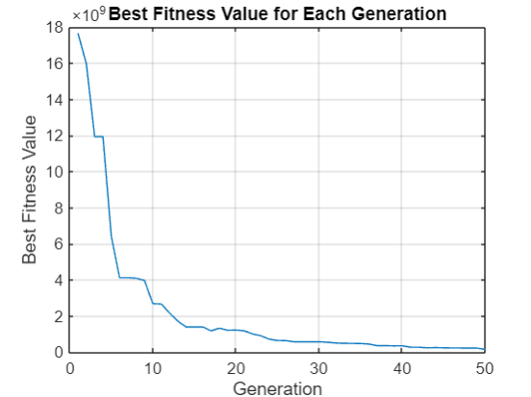
From the graph above, we can see how the best fitness value changes for 50 generations in a genetic algorithm. The X-axis is Generation which is the count of the generation, it should range from 0 to 50: a generation is the iteration in which the selection, crossover, and mutation operation are performed. The Y-axis is best fitness value, it will be taken the best value found for that generation, scale with 10 * 9. in this study, the fitness value representing how good the solution is and low is better. The blue line is drawn for the best fitness value for each generation, the value of the best fitness from high to decrease dramatically until nearly 10 generations. This indicates that the algorithm quickly found better solutions in the early generations. The algorithm continues the decrease line up to 10th generation, then this line gets less pitch inclination, and it continues to decrease gradually until 25th generation. After the 25th the line variability gets a more fluctuating chain, but it remains stable which means that the algorithm does not find significantly better solutions
Function1_2
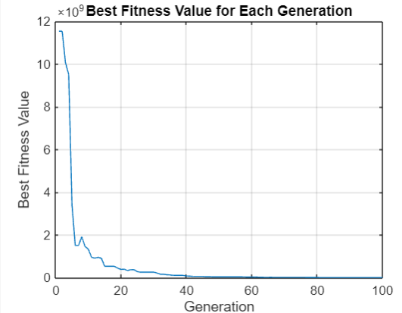
As we can observe from this graph, the best fitness value changes over 100 generations in a genetic algorithm. X-axis: Generation: The generation count which ranges from 0 to 100 in this graph. It refers to the number of generations or how many times the genetic algorithm has been iterated. Typically, in each generation, there is selection, crossover, and mutation. The Y-axis: Best Fitness Value: It refers to the best fitness value found in one generation but scaled by 10^9. The fitness value denotes how good a solution is, and in this example, the smaller the value, the better it is. Blue Line: This line refers to the best fitness value for each generation. It starts at generation 0 with about 9 x 10^9 and slops down incredibly fast.
Now as we finished the for the first fitness function now let’s see for the next fitness function which is
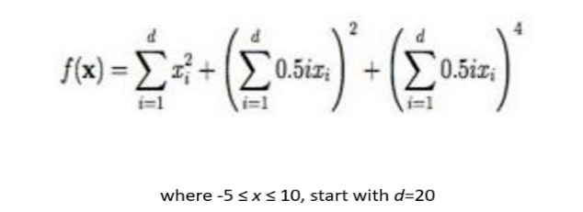
When we break down this fitness function into algorithmic view and define it like this fitness function = @(x) sum(x.^2) + (sum (0.5*(1: length(x)). *x)) ^2 + (sum (0.5*(1: length(x)). *x)) ^4;
Then we define the genetic algorithm parameters which includes:
- population size = 50;
- generations = 50;
- mutation rate = 0.20;
- crossover rate = 0.80;
Then we begin by initializing the population and each individual in the population as the 20-dimentional vector, within the range of -5 to 10 shown in the attached picture of the fitness function. We then create an array to hold the best fitness value found in each generation as shown: best fitness = zeros (generations, 1); After that, we then proceed to run the genetic algorithm which would be a loop starting with for gen = 1: generations. In this loop where several operations are performed which are:
- Fitness evaluation
- Tournament selection
- Crossover
- Mutation
- Population Replacement
- Storing best fitness value

Once the genetic algorithm has executed the given number of generations, in this case, 50 we have created a plot that displays the best fitness value discovered at each generation. Understanding the algorithm’s progress might be helpful in fine-tuning its parameters. More about we are going to change its population and generation to 100 and see the best fitness value for this. Hence the name given to the first generation of phenotypic and genetic which is generation and population is 50 we named as function2_1 whereas the second generation of the function and whose generation and population are 100 we will name as function2_2.

Now let’s see the graphs for both generations

Function2_1

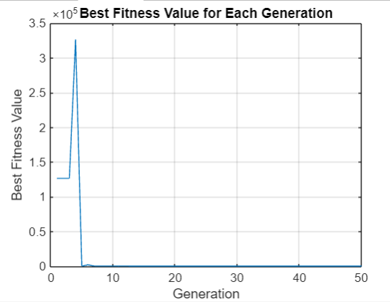

This graph illustrates the best fitness value varies over 50 generations after running the genetic algorithm. X-axis: generation. It refers to the number of generations. Each generation is calculated by running the selection, crossover, and mutation on the parents’ populations to generate the offspring impart. The Y-axis: best fitness value. It is the best value from the fitness values for each generation after scaling by 10^9, and to explain, the fitness value is assigned to the solution, with a lower value is the best. Finally, the blue line represents the best fitness value of each generation. It assumes a large value and lowers Accelerated until generation 10. This indicates that the algorithm quickly found better solutions in the early generations. After the 10th generation, the line shows fluctuations but follows a general downward trend towards the 50th generation.

Function2_2

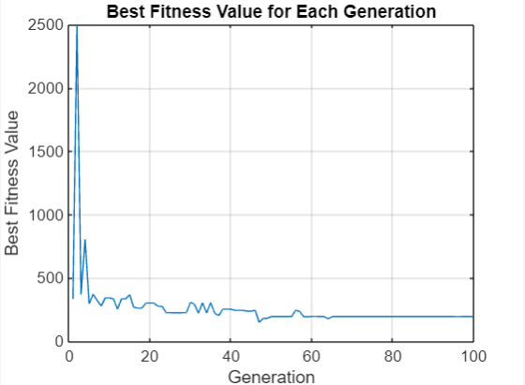

The graph below shows how the best fitness value changes over 50 generations in a genetic algorithm. X-axis: This is the generation, it shows the number of generation in the genetic algorithm taken by the algorithm best case: starts from 0 and goes up to a hundred generations. Y-axis: best fitness value, it shows the best value in each generation best case; starts at 0 and goes up to 2.5 million, which means the fitness values are quite large * Blue line : this line shows the best value the algorithm could find in each generation. The blue line is heading high at the start, which means analyzes the optimality objective value, then it declines as the function found a really good solution but after that, After this initial drop, the line flattens out significantly, indicating that the fitness value didn’t improve much in the subsequent generations.

4 CONCLUSIONS

section one AI ethical issues solution

Deepfake Technology:
Enforce rules to combat deepfake content and misuse cutting-edge detection tools, such as those provided by startups, and trusted partnerships across firms and law enforcement officers.
AI Ecosystems Privacy, Security, and Responsibility:
Develop technologies to protect privacy gates and establish credibility. Enforce cybersecurity across major areas, such as healthcare, self-driving cars. Assure that AI enables interdisciplinary committees to oversee ethical AI development.
Mitigating Bias and Discrimination in AI:
Seek for transparency in AI models and datasets. Promote people upping AI teams. Encourage discussion.
Ethical Concerns in AI Implementation:
Integrate the values of openness, duty, and equity while employing AI. Inquire about a variety of people’s knowledge and perspectives when creating about how Ai’s put into use.
Job Displacement and Economic Impact:
Regard and support people who engage in retraining programs and offer financial assistance to displaced workers.

Section two Genetic Algorithms ethical issues solutions

The most prominent approach of improving the transparency of the algorithms in scale is establishing a straightforward visualization tool that exhibits the development of solutions across generations. This tool would provide easy to comprehend illustrations of changes in candidate solutions over time, focusing on key evolutionary steps, including Crossover, mutation, and selection. Additionally, transparency can also be achieved through the incorporation of an explanation mechanism that logs and displays decision-making progression in specific iterations. This approach entails understanding why some solutions are being selected or discarded depending on evidence such as fitness evaluation or genetic operator application. Additionally, one can also increase transparency in the algorithm through increased awareness and educating users and other stakeholders regarding the algorithm’s limitations and biases. This educational endeavour might involve the provision of documentation, training resources, and workshops that explain the algorithm concepts, as well as the variables which could influence the operations or decision-making. Using some smaller scale approaches, developers can

foster an algorithm transparency that does not require the resource or major reforms of the existing systems.

REFERENCES
“Regulating deep fakes: legal and ethical Considerations” by Edvinas Meskys, Aidas Liaudanskas, Julija Kalpokiene and Paulius Jurcys
“Face Recognition: From Traditional to Deep Learning Methods” by Daniel Saez Trigueros, Li Meng School of Engineering and Technology University of Hertfordshire Hatfield AL10 9AB, UK
“Privacy of the Metaverse: Current Issues, AI Attacks, and Possible Solutions” by Chamara Sandeepa and Madhusanka Liyanage
"The Ethical Implications of Artificial Intelligence" by John H. Conway and Simon O'Brien
"Ethical Issues in Artificial Intelligence" by Patricia H. Werhane and R. Edward Freeman
"Artificial Intelligence and Ethics: A Survey" by Margaret A. Boden
"Genetic Algorithms and the Traveling Salesman Problem" by David E. Goldberg.
"Genetic Algorithms in Search, Optimization and Machine Learning" by Christine A. Rice.
"Genetic Algorithms: A Guide to Evolutionary Computation" by Richard L. Hardy.
"Applications of Genetic Algorithms" by Sandeep K. Kumar and Kalyan Moy Deb.
"A Survey of Genetic Names for Evolutionary Computation" by Karen M. Rhodes and Mark J. keep.
"Evolutionary Computation and Genetic Programming" by Peter J. Bentley and Richard E. Lutton
.
Source code as an appendix

Appending the code here for function1_1:
rng(42);

% Defining the fitness function
fitness_function = @(x) sum(100*(x(2:end)-x(1:end-1).^2).^2 + (1-x(1:end-1)).^2);

% Defining the genetic algorithm parameters
population_size = 50;
generations = 50;
mutation_rate = 0.20;
crossover_rate = 0.80;

% Initializing the population
population = -100 + (100-(-100)).*rand(population_size, 20); % 20-dimensional population

% Initializing the best fitness array
best_fitness = zeros(generations, 1);

% Run the genetic algorithm
for gen = 1:generations
% Evaluate the fitness of each individual
fitness = zeros(population_size, 1);
for i = 1:population_size
fitness(i) = fitness_function(population(i,:));
end

% Store the best fitness value for this generation
best_fitness(gen) = min(fitness);
fprintf('Generation %d: Best fitness = %f\n', gen, best_fitness(gen));

% Selecting parents using tournament selection
parents = zeros(population_size, 20);
for i = 1:population_size
idx = randi([1 population_size], 2);
if fitness(idx(1)) < fitness(idx(2))
parents(i,:) = population(idx(1),:);
else
parents(i,:) = population(idx(2),:);
end
end

% Performing crossover
offspring = zeros(population_size, 20);
for i = 1:2:population_size
if rand < crossover_rate
parent1 = parents(i,:);
parent2 = parents(i+1,:);
crossover_point = randi([1 length(parent1)]);
offspring(i,:) = [parent1(1:crossover_point) parent2(crossover_point+1:end)];
offspring(i+1,:) = [parent2(1:crossover_point) parent1(crossover_point+1:end)];
else
offspring(i,:) = parents(i,:);
offspring(i+1,:) = parents(i+1,:);
end
end

% Performing mutation
for i = 1:population_size
if rand < mutation_rate
mutation_point = randi([1 length(offspring(i,:))]);
offspring(i,mutation_point) = -100 + (100-(-100)).*rand;
end
end

% Replacing the population with the new offspring
population = offspring;
end

% Plotting the best fitness value for each generation
figure;
plot(1:generations, best_fitness);
title('Best Fitness Value for Each Generation');
xlabel('Generation');
ylabel('Best Fitness Value');

Appending the code here for function1_2:
rng(42);

% Defining the fitness function
fitness_function = @(x) sum(100*(x(2:end)-x(1:end-1).^2).^2 + (1-x(1:end-1)).^2);

% Defining the genetic algorithm parameters
population_size = 100;
generations = 100;
mutation_rate = 0.20;
crossover_rate = 0.80;

% Initializing the population
population = -100 + (100-(-100)).*rand(population_size, 20); % 20-dimensional population

% Initializing the best fitness array
best_fitness = zeros(generations, 1);

% Run the genetic algorithm
for gen = 1:generations
% Evaluate the fitness of each individual
fitness = zeros(population_size, 1);
for i = 1:population_size
fitness(i) = fitness_function(population(i,:));
end

% Store the best fitness value for this generation
best_fitness(gen) = min(fitness);
fprintf('Generation %d: Best fitness = %f\n', gen, best_fitness(gen));

% Selecting parents using tournament selection
parents = zeros(population_size, 20);
for i = 1:population_size
idx = randi([1 population_size], 2);
if fitness(idx(1)) < fitness(idx(2))
parents(i,:) = population(idx(1),:);
else
parents(i,:) = population(idx(2),:);
end
end

% Performing crossover
offspring = zeros(population_size, 20);
for i = 1:2:population_size
if rand < crossover_rate
parent1 = parents(i,:);
parent2 = parents(i+1,:);
crossover_point = randi([1 length(parent1)]);
offspring(i,:) = [parent1(1:crossover_point) parent2(crossover_point+1:end)];
offspring(i+1,:) = [parent2(1:crossover_point) parent1(crossover_point+1:end)];
else
offspring(i,:) = parents(i,:);
offspring(i+1,:) = parents(i+1,:);
end
end

% Performing mutation
for i = 1:population_size
if rand < mutation_rate
mutation_point = randi([1 length(offspring(i,:))]);
offspring(i,mutation_point) = -100 + (100-(-100)).*rand;
end
end

% Replacing the population with the new offspring
population = offspring;
end

% Plotting the best fitness value for each generation
figure;
plot(1:generations, best_fitness);
title('Best Fitness Value for Each Generation');
xlabel('Generation');
ylabel('Best Fitness Value');

Appending the code here for function2_1 :
Appending the code here for function2_1:
rng(42);

% Defining the fitness function
fitness_function = @(x) sum(x.^2) + (sum(0.5*(1:length(x)).*x))^2 + (sum(0.5*(1:length(x)).*x))^4;

% Defining the genetic algorithm parameters
population_size = 50;
generations = 50;
mutation_rate = 0.20;
crossover_rate = 0.80;

% Initializing the population
population = -5 + (10-(-5)).*rand(population_size, 20); % 20-dimensional population

% Initializing the best fitness array
best_fitness = zeros(generations, 1);

% Runnin the genetic algorithm
for gen = 1:generations
% Evaluate the fitness of each individual
fitness = zeros(population_size, 1);
for i = 1:population_size
fitness(i) = fitness_function(population(i,:));
end

% Selecting parents using tournament selection
parents = zeros(population_size, 20);
for i = 1:population_size
idx = randi([1 population_size], 2);
if fitness(idx(1)) < fitness(idx(2))
parents(i,:) = population(idx(1),:);
else
parents(i,:) = population(idx(2),:);
end
end

% Performing crossover
offspring = zeros(population_size, 20);
for i = 1:2:population_size
if rand < crossover_rate
parent1 = parents(i,:);
parent2 = parents(i+1,:);
crossover_point = randi([1 length(parent1)]);
offspring(i,:) = [parent1(1:crossover_point) parent2(crossover_point+1:end)];
offspring(i+1,:) = [parent2(1:crossover_point) parent1(crossover_point+1:end)];
else
offspring(i,:) = parents(i,:);
offspring(i+1,:) = parents(i+1,:);
end
end

% Performing mutation
for i = 1:population_size
if rand < mutation_rate
mutation_point = randi([1 length(offspring(i,:))]);
offspring(i,mutation_point) = -100 + (100-(-100)).*rand;
end
end

% Replacing the population with the new offspring
population = offspring;

% Store the best fitness value
best_fitness(gen) = min(fitness);
fprintf('Generation %d: Best fitness = %f\n', gen, best_fitness(gen));
end

% Plotting the best fitness value for each generation
figure;
plot(1:generations, best_fitness);
title('Best Fitness Value for Each Generation');
xlabel('Generation');
ylabel('Best Fitness Value');

Appending the code here for function2_1 :

Appending the code here for function2_2:
rng(42);

% Defining the fitness function
fitness_function = @(x) sum(x.^2) + (sum(0.5*(1:length(x)).*x))^2 + (sum(0.5*(1:length(x)).*x))^4;

% Defining the genetic algorithm parameters
population_size = 100;
generations = 100;
mutation_rate = 0.20;
crossover_rate = 0.80;

% Initializing the population
population = -5 + (10-(-5)).*rand(population_size, 20); % 20-dimensional population

% Initializing the best fitness array
best_fitness = zeros(generations, 1);

% Runnin the genetic algorithm
for gen = 1:generations
% Evaluate the fitness of each individual
fitness = zeros(population_size, 1);
for i = 1:population_size
fitness(i) = fitness_function(population(i,:));
end

% Selecting parents using tournament selection
parents = zeros(population_size, 20);
for i = 1:population_size
idx = randi([1 population_size], 2);
if fitness(idx(1)) < fitness(idx(2))
parents(i,:) = population(idx(1),:);
else
parents(i,:) = population(idx(2),:);
end
end

% Performing crossover
offspring = zeros(population_size, 20);
for i = 1:2:population_size
if rand < crossover_rate
parent1 = parents(i,:);
parent2 = parents(i+1,:);
crossover_point = randi([1 length(parent1)]);
offspring(i,:) = [parent1(1:crossover_point) parent2(crossover_point+1:end)];
offspring(i+1,:) = [parent2(1:crossover_point) parent1(crossover_point+1:end)];
else
offspring(i,:) = parents(i,:);
offspring(i+1,:) = parents(i+1,:);
end
end

% Performing mutation
for i = 1:population_size
if rand < mutation_rate
mutation_point = randi([1 length(offspring(i,:))]);
offspring(i,mutation_point) = -100 + (100-(-100)).*rand;
end
end

% Replacing the population with the new offspring
population = offspring;

% Store the best fitness value
best_fitness(gen) = min(fitness);
fprintf('Generation %d: Best fitness = %f\n', gen, best_fitness(gen));
end

% Plotting the best fitness value for each generation
figure;
plot(1:generations, best_fitness);
title('Best Fitness Value for Each Generation');
xlabel('Generation');
ylabel('Best Fitness Value');

